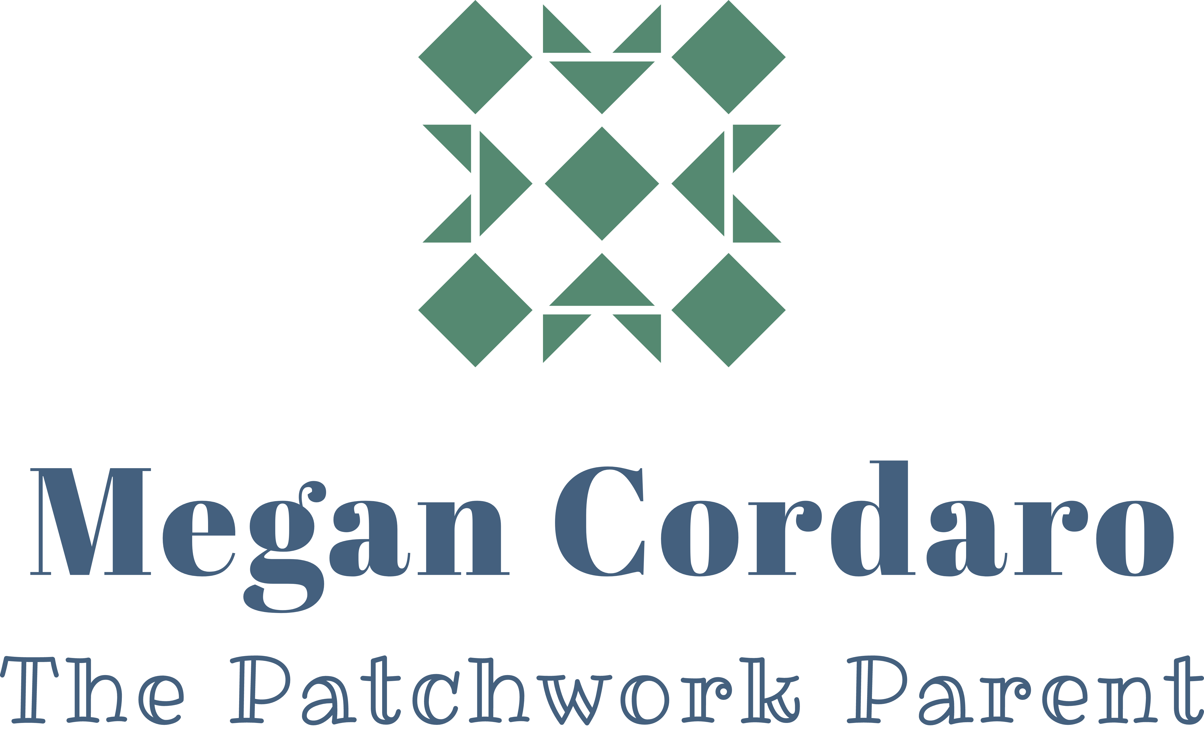
Terms and Conditions for
Willow Tree Parenting Workshop

Thank you for trusting me with the honor of helping you achieve your vision for you, your family, and your home.

As your workshop coach, you can expect me to:
  - be a confident and respectful group leader
  - support you in setting goals and taking the steps to meet your goals.
  - provide careful listening, powerful questions, and honest feedback.
  - provide support in-between sessions, via email and through the forum. I commit to responding to you within 24 hours.

As my client, I expect that you will:
• be honest with yourself and with the group.
• commit to goals that are meaningful to you.
• take ownership for your progress and your accomplishments, including completing any individual work encouraged to be completed in-between sessions.
• respect the confidentiality of this agreement and what is shared in all our time together.
  - maintain an attitude of participation, collaboration, and a willingness to engage
in the transformation process

Ground Rules for Group:
The following ground rules facilitate the development of trust in the group and enable us to share our thoughts and feelings with each other.
  - Because confidentiality is essential, we expect that each person will respect and maintain the confidentiality of the group. What is said in the group is not to be repeated or discussed at any other time or place.
  - We are here to share our own feelings and experiences; we try not to give advice.
  - We accept people, just as they are, and we avoid making judgments.
  - We try to give everyone an opportunity to share.
  - We have the right to speak and the right to remain silent.
  - We give supportive attention to the person who is speaking and avoid side conversations.
  - We avoid interrupting. If we do break in, we return the conversation to the person who was speaking.
  - We do not discuss group members who are not present.
  - If there are repeated breeches of any of these rules by a member of the group, I reserve the right to terminate their participation in the group.

Payment Procedures
Payments for all services are required to be made prior to the start of the first class. Payment will be accepted by Venmo, PayPal, or Square.

Zoom Calls
Zoom calls will begin on time. Please log in a few minutes early so we can begin right away. I will do my best to keep our group on track and be respectful of your time, as well. Zoom calls will be recorded, but we will all get the most out of each session if we are all participating together, so please attend.

Pre-recorded Videos
Please take the time to watch the pre-recorded videos in between the live Zoom calls, as this will allow you to get the most out of our limited time together.

Communication in-between Calls
I will be communicating with you in-between zoom sessions via email. I may direct you to the forum for more details, but the primary form of communication will be email, so please be sure you add me to your contacts and read emails from me.

Forum
Due to us not being able to spend time together in person, I want to have a space for communication in-between sessions; this space will be an online forum on my website. As this is a parenting workshop where we will be sharing personal and vulnerable information, it is of upmost importance that the Ground Rules for the Group are adhered to online in the forum, just as they would in-person.

Confidentiality and Informed Consent
I protect the confidentiality of all my clients. I will only release information about our work with your written permission or if I am required to do so by a court of law. Breaches of confidentiality, in which I am obligated to report confidential information, are specific in only two instances:
1 If I have information that indicates that a child, elderly, or disabled person is being abused or neglected I am obligated by law to report this information to the appropriate local agencies for the protection of that person.
2 If a client is in imminent risk to him/herself or makes threats of imminent violence against another person, I am required by law to report this to the appropriate local agencies for protective action.
Though these situations rarely occur within group or parent coaching sessions, when and if they do occur, I will do my best to communicate in advance any necessary and legally obligated protective action that I may take.

Group Work/Parent Coaching and Psychotherapy
Coaching services aim to increase parenting confidence, comfort, and parent-child relationships. This is done by encouraging you to make significant behavior and lifestyle changes to incorporate new skills. Psychotherapy is a health service that includes mental health practitioners with training and experience in diagnosing and treating emotional and psychological problems. The coaching provided does not include psychotherapy or any other health care service.

Workshop participation does not offer any guarantee of success or definitive changed behavior of you or your child, but the more one is committed to change, the more beneficial the experience can be.

By registering for a Parenting Workshop, you agree to the following:
• I agree to all terms and conditions above and am committed to the process of change.
• I understand that involvement in this workshop does not involve the diagnosis or treatment of mental disorders as defined by the American Psychiatric Association.
• I understand that involvement in the workshop is not a substitute for counseling, psychotherapy, psychoanalysis, mental health care, or substance abuse treatment. I will not use it in place of any form of diagnosis, treatment or therapy.

In completing your online registration for the Parenting Workshop and checking the Terms and Conditions box, you indicate that you have read the information in this agreement and agree to abide by all its terms and conditions during the Worskshop. I appreciate your trust and the opportunity to serve you!

Signed,

Megan Cordaro
____________________________________
Megan Cordaro, MSW/Parent Coach

megan.cordaro@gmail.com
310 995 7100

